Product Specifications Special Chemicals
Substance name | 2,4-Hexadienoic acid
Synonym name | Sorbic acid
Art No.
CAS No. 110-44-1 |  |  | Country of origin | Germany
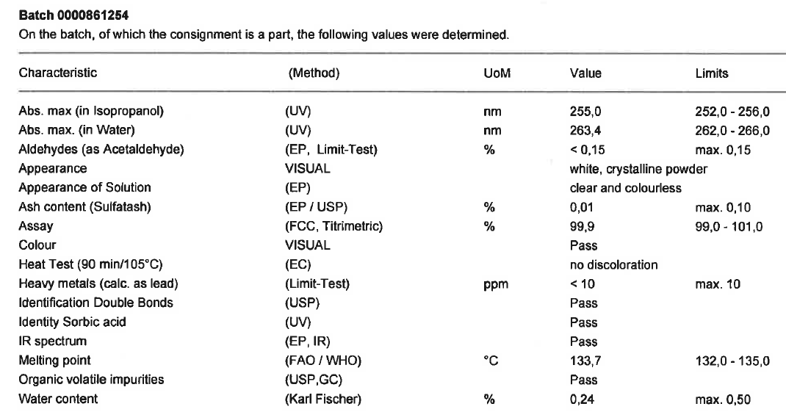

 |  | Aug. 24th, 2018
Issued by: |  | BR
The above identified product conforms to the standard as specified in all requirements. All data as mentioned have been copied from the original certificate received from the supplier. The above results do not relieve the customer from his obligation to carry out his own controls upon receipt of goods and cannot be regarded as a guaranty. We hereby do not assume any liability beyond the individual contract.
This certificate is an electronic copy of the certificate available in the laboratory and does not require signature
CHEMOS GmbH & Co. KG, Werner-von-Siemens-Str. 3, D-93128 Regenstauf
Tel. 0049 9402 9336 0, Fax. 0049 9402 9336 13, sales@chemos-group.com, www.chemos.de

